**DAILY ONLINE ACTIVITIES SUMMARY**

|  |  |  |  |  |  |  |
| --- | --- | --- | --- | --- | --- | --- |
| **Date:** | **15/06/2020** | | | **Name:** | **Chandana Patil** | |
| **Sem & Sec** | **6th Sem & A Sec** | | | **USN:** | **4AL17CS020** | |
| **Pre-Placement Training Summary** | | | | | | |
| **Pre placement training** | **9:00 am to 11:00 am - Programming in C**  **11:00 am to 1:00pm - Applications of python in DA and ML** | | | | | |
| **Faculty** | | **1.Vivek Sharma**  **2.Dr. Mohideen Badhusha** | **Duration** | | | **-** |
| **Assessments** | | | | | | |
| **Problem Statement:**   1. C program to count number of distinct elements in an array. 2. Examples and Exercises on python. | | | | | | |
| **Status: Completed** | | | | | | |
| **Uploaded the report in GitHub** | | | **Yes** | | | |
| **If yes Repository name** | | | [**https://github.com/chandanapatil/PrePlacement-Training.git**](https://github.com/chandanapatil/PrePlacement-Training.git)  [**https://github.com/chandanapatil/Application-of-Python-Programming-in-DA-and-ML.git**](https://github.com/chandanapatil/Application-of-Python-Programming-in-DA-and-ML.git) | | | |
| **Uploaded the report in slack** | | | **Yes** | | | |

**Python(Workshop quiz):**

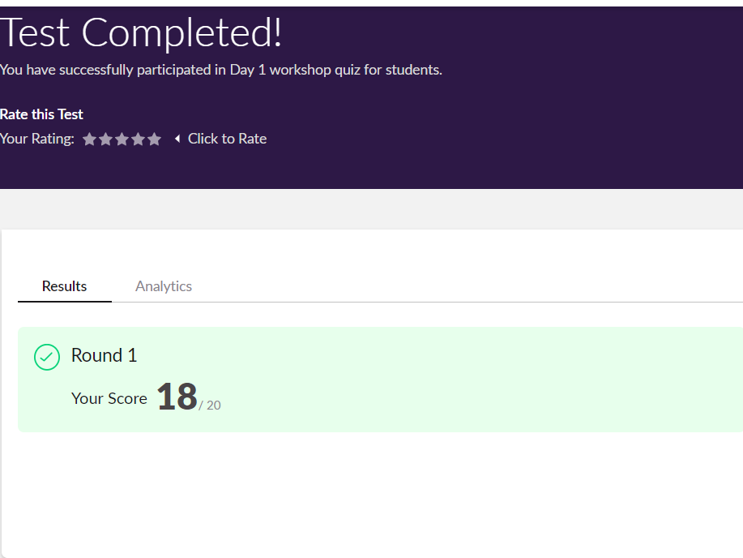

**Training snapshots:**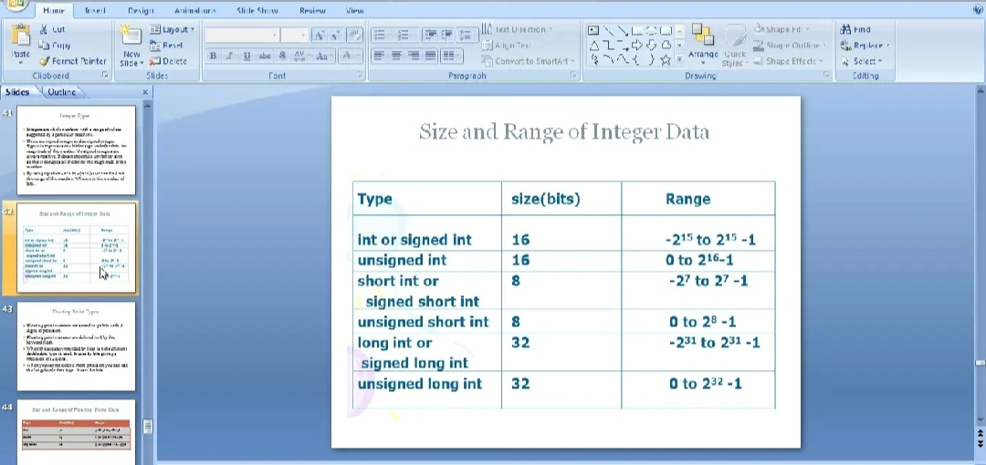

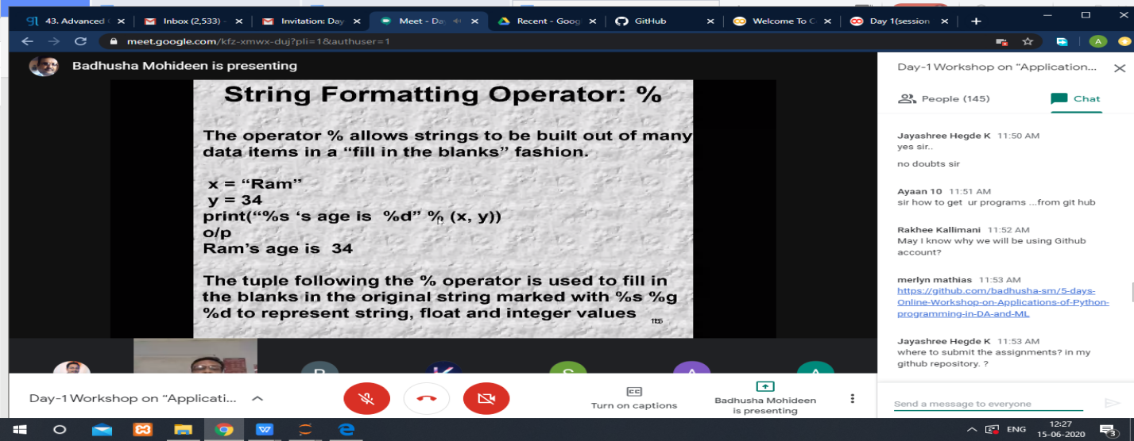

**Assessments:**

**Uploaded in GitHub account and respective links are provided below.**

**C programming:**

[**https://github.com/chandanapatil/PrePlacement-Training.git**](https://github.com/chandanapatil/PrePlacement-Training.git)

**Python programming:**

[**https://github.com/chandanapatil/Application-of-Python-Programming-in-DA-and-ML.git**](https://github.com/chandanapatil/Application-of-Python-Programming-in-DA-and-ML.git)